Business Requirements Document(BRD) Template
TravelMate Hotel Search & Filtering Module
May 2026
Version 1.0

Company Information TravelMate Inc.

Document Revisions
Date | Version Number | Document Changes
05/21/2026 | 1.0 | Completed initial requirements configuration based on User Survey and Business Owner Interview data.

Approvals
Role | Name | Title | Signature | Date
Business Analyst | Ivan Kucher | Lead Business Analyst | Prepared & Released | 05/21/2026
Business Owner | Oleksandr Kovalenko | Client / Platform Sponsor | Approved via JIRA | 05/21/2026
Product Manager | Olena Petrova | Product Owner | Approved via JIRA | 05/21/2026
Tech Lead | Dmytro Semeniuk | Chief Software Architect | Approved via JIRA | 05/21/2026
Lead QA | Iryna Melnyk | QA Manager | Approved via JIRA | 05/21/2026

Introduction

Project Summary

Objectives
This project covers the development of the core Search and Filtering Module for the TravelMate platform. The module enables users to find, filter, and view hotel accommodations in real-time based on specific travel parameters.

Background
Based on user feedback, travelers experienced delays and a lack of transparency regarding total prices during hotel searches. Concurrently, the business required a mechanism to promote high-margin partner hotels and synchronize room inventory in real-time to prevent double-bookings.

Business Drivers
- Financial: Maximizing commission revenue from bookings by strategically displaying high-margin partner hotels at the top of search results.
- Operational: Reducing manual data verification and double-booking errors through automated, real-time inventory synchronization via Channel Manager APIs.
- Market: Increasing customer retention and platform loyalty by delivering an ultra-fast (under 1.5 seconds) and mobile-responsive interface for travelers on the move.

Project Scope

In Scope Functionality

- Dynamic Search Panel: Input fields for Destination (with autocomplete), Check-in/Check-out calendar (highlighting weekends), and guest counters specifying children's exact ages.
- Multi-Criteria Filtering: Real-time search adjustments using a price slider, verified review scores (minimum 8+), Free Cancellation toggles, and amenity checkboxes (Wi-Fi, parking, breakfast).
- Consolidated Card Layout: Hotel cards displaying total aggregate price for the full stay duration, a main room picture, and exact distance indicators to the city center.
- Map Integration: Responsive toggle allowing mobile users to view search results on an interactive map with geographical price pins.
- Revenue Optimization System: Priority placement for "Recommended" partner listings and dynamic marketing badges showcasing room scarcity ("Only 1 room left!").
- Demand Analytics Framework: Logging background system events when active filters yield zero results for market analysis.

Out of Scope Functionality

- Core payment gateway integrations and actual credit card transaction processing channels.
- Internal property management systems (PMS) or listing dashboards dedicated to hotel owners.
- Flight reservations or car rental add-ons within the TravelMate platform.

System Perspective

Assumptions

- Hotel partners and channel managers will provide stable, high-speed, and well-documented API connections for seamless, live room inventory updates.

Constraints
- The module must fully comply with global data protection laws (GDPR) regarding user tracking.
- The search interface must be highly optimized to run smoothly on slow mobile networks (3G).

Risks
- .External hotel management systems might experience technical delays, causing temporary data mismatches or brief double-booking issues on our platform.

Issues
- No blocking issues or unresolved problems have been identified at this initial drafting stage.

Business Process Overview

Current Business Process (As-Is)
Currently, travelers search for hotels through static web pages. Property inventory and nightly rates are updated manually by operators once a day. Users must check calendar dates without seeing weekend highlights, prices are displayed only per single night (hidden fees appear at checkout), and room availability is not verified in real-time, often leading to customer frustration due to manual confirmation delays.
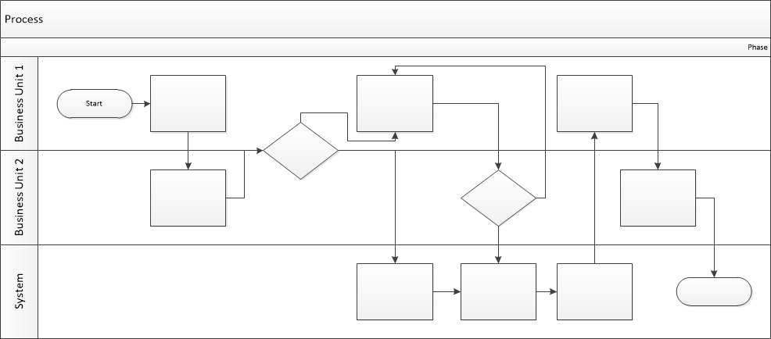

Proposed Business Process (To-Be)
The new system introduces an automated, real-time property discovery process. The traveler enters travel parameters (destination autocomplete, calendar with weekend indicators, and specific child ages) into the dynamic search bar. The platform instantly queries unified databases and channel managers via API, applying algorithmic priority to recommended partner hotels and displaying eye-catching scarcity badges. Results are displayed as comprehensive hotel cards showing total stay prices and distances to landmarks, with an instant toggle to a responsive map view.

1. The traveler enters travel parameters (destination autocomplete, check-in/check-out dates, and numbers of guests including exact children's ages) into the search panel.
2. The system instantly queries unified databases and hotel channel managers via API to check live room availability and calculate exact pricing tiers.
3. The system processes the results, automatically prioritizing recommended partner hotels and applying promotional marketing badges ("Only 1 room left!", "Best Price").
4. The system renders comprehensive hotel cards displaying the total aggregate price for the full stay duration, primary photos, review scores, and exact distances to landmarks.
5. The traveler reviews the list or switches to an interactive mobile-responsive map view with geographical price pins to choose the perfect hotel.



Stakeholder Requirements

The requirements in this document are prioritized as follows:
Value | Rating | Description
1 | Critical | This requirement is critical to the success of the project. The project will not be possible without this requirement.
2 | High | This requirement is high priority, but the project can be implemented at a bare minimum without this requirement.
3 | Medium | This requirement is somewhat important, as it provides some value but the project can proceed without it.
4 | Low | This is a low priority requirement, or a “nice to have” feature, if time and cost allow it.
5 | Future | This requirement is out of scope for this project, and has been included here for a possible future release.

Functional Requirements
Req# | Priority | Description | Rationale | Use Case Reference | Impacted Stakeholders
General / Base Functionality
FR-G-001 | 1 | The system must accept search inputs for Destination (with autocomplete text), Check-in/Check-out dates (highlighting weekends), and total guests specifying individual children's exact ages. | Captures precise family and calendar parameters required to calculate accurate room occupancy capacities and correct family pricing tiers. | UC-Search-01 | End Traveler
FR-G-002 | 1 | The default search results page must sort and display "Recommended" properties (based on higher business margin or affiliate agreements) at the top of the list view. | Directly drives corporate profitability and satisfies monetization strategies agreed upon with partner hotel chains. | UC-Sort-01 | Business Owner
FR-G-003 | 1 | The system must dynamically overlay psychological marketing tags (e.g., "Only 1 room left!", "Best Price") on prioritized partner hotel listing cards based on live inventory availability. | Applies scarcity and value psychology to nudge user selection, accelerating the conversion rate from search to active booking. | UC-Display-02 | Business Owner, End Traveler
FR-G-004 | 1 | Each hotel card must explicitly display the total calculated cost for the entire stay period, a main room photo, review score, and exact distance to the city center. | Provides absolute financial and visual transparency upfront, drastically reducing customer drop-out rates caused by hidden checkout fees. | UC-Display-01 | End Traveler
FR-G-005 | 1 | The system must enable dynamic multi-filtering using a pricing slider, verified review scores (>= 8+), Free Cancellation checkbox, and basic amenities checkboxes (Wi-Fi, parking, breakfast). | Allows users to instantly isolate properties meeting their exact travel preferences, improving customer satisfaction and interface speed. | UC-Filter-01 | End Traveler
Security Requirements
FR-S-001 | 1 | The system must securely encrypt user session tokens and mask personal identifiers during external API requests to hotel systems. | Guarantees international data privacy compliance and protects users' personal search histories. | UC-Sec-01 | End Traveler, Business Owner
Reporting Requirements
FR-R-001 | 2 | The system must automatically capture and log metadata (destination, price caps, features) whenever a user's applied filters yield zero results. | Provides the business owner with immediate market demand data regarding property deficits to guide future hotel acquisitions. | UC-Analytics-01 | Business Owner
Usability Requirements
FR-U-001 | 1 | The interface must provide a responsive toggle button allowing users to instantly switch between a standard vertical list grid and an interactive map view with price pins. | Delivers vital context for mobile travelers who prefer to make property selections based on exact geographical and pricing layouts. | UC-UI-01 | End Traveler
Audit Requirements
FR-A-001 | 1 | The system must generate automated logs for every API inventory synchronization event to trace data updates from external channel managers. | Ensures precise system auditing logs are available to troubleshoot technical booking errors or pricing discrepancies. | UC-Audit-01 | Hotel Partners, Business Owner

Non-Functional Requirements

ID | Requirement
NFR-001 | The search and filtering engine must process property dataset queries and render results on the client screen within 1.5 seconds under maximum peak traffic load.
NFR-002 | The system must synchronize room inventory statuses with external Channel Manager APIs and remove occupied rooms from search outputs within 5 seconds.
NFR-003 | The empty-filter logging engine must execute background operations asynchronously, adding no more than 100ms of latency to the user session.
NFR-004 | Under slow network connections (e.g., 3G environments), the interface must automatically defer heavy imagery and render optimized, lightweight asset placeholders first.
NFR-005 | The user interface layouts, interactive sliders, and map overlays must dynamically adapt across standard mobile phone screen viewports.

Appendices

List of Acronyms
- API: Application Programming Interface
- BRD: Business Requirements Document
- GDPR: General Data Protection Regulation
- PMS: Property Management System
- UI: User Interface

Glossary of Terms
- Autocomplete: A smart software function that predicts and suggests the rest of a word or city name as the user types.
- Channel Manager: A cloud-based software that synchronizes hotel room availability and prices across multiple travel and booking platforms simultaneously.
- Conversion Rate: The percentage of platform users who transition from just searching for a hotel to actively completing a booking.
- Real-Time Synchronization: Instantaneous operational data updates between our platform and external hotel databases happening within seconds.
- Scarcity Badge: A visual marketing tag on a property card (e.g., "Only 1 room left!") used to inform users about limited room availability.

Related Documents
- TravelMate Core Product Vision & Strategy (2026)
- User Survey Report: Accommodation Discovery Preferences (May 2026)
- Business Stakeholder Interview Transcript: Hotel Search Monetization (May 2026)

